Login as root

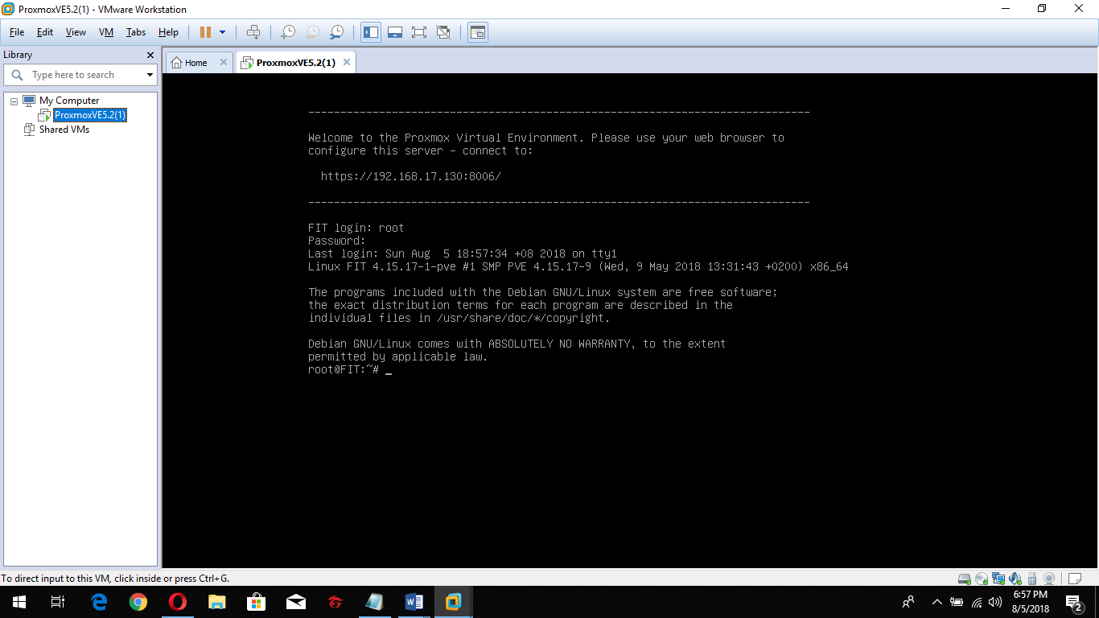

Type command line “systemctl status open-vm-tools.service”

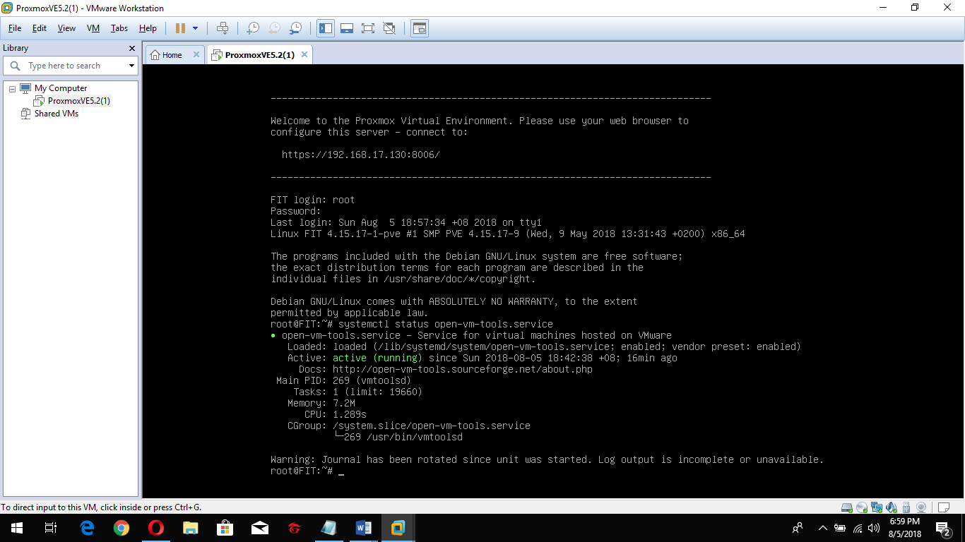

Type “exit”

